Rabies Vaccine Labelling
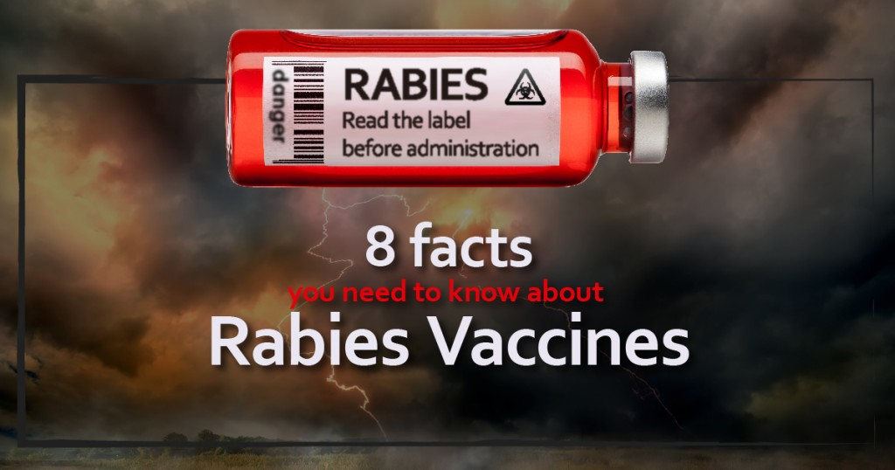
You might have noticed that rabies vaccines are labelled for either one year or three years. What is the difference between the two vaccines? The answer is that there is no difference. It is the exact same vaccine. Veterinary immunologist Dr. Ronald Schultz states: “There is no benefit from annual rabies vaccination and most one year rabies products are similar or identical to the 3-year products with regard to duration of immunity and effectiveness. However, if they are 1 year rabies vaccines, they must be legally given annually! Rabies vaccine is the only canine vaccine requiring a minimum duration of immunity study. However, revaccination annually does not necessarily improve immunity. However, annual vaccination does significantly increase the risk for an adverse reaction in the dog.”

Biological Drugs vs. Pharmaceutical Drugs
“I tell practitioners that vaccines are drugs, albeit biological drugs. I remind them that they would not consider it good medicine to give an unnecessary pharmaceutical drug on a recurring basis. I think it is even worse to give a vaccine, or biological drug, that isn’t necessary. The possible adverse consequences of a vaccine generally far outweigh the adverse consequences of a pharmaceutical drug. A pharmaceutical drug is usually much more restricted in its action. However, each time we stimulate an immune response, we have to look at the effect on all body systems—not only on antibody responses or cell-mediated immunity, but also on interactions with the endocrine system and the nervous system.”

Lacking Long Term Studies
The annual revaccination recommendation on the vaccine label is just that: a recommendation without the backing of long term duration of immunity studies, and, surprisingly, it is not a legal requirement. Rabies vaccine is the only commonly used vaccine that requires that duration of immunity studies be carried out before licensing in the United States. Even with rabies vaccines, the label may be misleading in that a three year duration of immunity product may also be labelled and sold as a one year duration of immunity product.

All of the Risk, No Benefit
In 2009, Alabama became the last state to allow dog owners to vaccinate their dogs every three years instead of annually. Dr. Dee Jones, Alabama Public Health Veterinarian states that veterinarians may use rabies vaccine “in accordance to its label” in a letter written to state vets. “The state is now recognizing and accepting the use of a three-year vaccine that is labelled for such,” he wrote. “However, it is worth belabouring that the state is not mandating the use of three-year vaccine. The decision to use a one-year or a three-year rabies vaccine lies entirely with the veterinarian and the animal owner.” Despite Dr. Schultz’s efforts at educating veterinarians, your veterinarian is allowed to inject your dog annually with what is essentially a three year vaccine. This means he gets all of the risk and none of the benefit. Before you give your vet the benefit of the doubt when he urges you to vaccinate annually, consider what Dr. Schultz has to say about how well most veterinarians understand immunity.

A Lack of Understanding
Dr. Schultz states: “many practitioners really don’t understand the principles of vaccinal immunity. A significant number of practitioners believe the annual revaccination recommendation on the vaccine label is evidence the product provides immunity for (only) one year. This is simply not true.

Legal Requirement Claims
Many practitioners also believe that they are legally required to vaccinate annually and if they don’t they will not be covered by AVMA liability insurance if the animal develops a vaccine preventable disease – Not True. Furthermore, certain companies will not provide assistance if practitioners don’t vaccinate annually with core vaccines. Not True – In fact most of the companies have now demonstrated their core products provide at least 3 years of immunity.

Revaccination
There is also a belief that not revaccinating will cause the animal to become susceptible soon (days or a few weeks) after the one year. – Not True. Or that if the animal is not revaccinated at or before one year the “whole vaccination program needs to be started again”. – Not True. Some vets have gone on to say that if they don’t continue to revaccinate annually, diseases like canine distemper, canine parvovirus and infectious canine hepatitis (CA V-I) will “reappear and cause widespread disease similar to what was seen prior to the development of vaccines for these diseases.” – Not True. If revaccination “doesn’t help, it won’t hurt.” – Not True

“Better” Immunity
Some vets have suggested that giving a vaccine annually that has a duration of immunity of 3 or more years provides much better immunity than if the product is given only once during the three years. – Not True. As well as regional/state rabies programs that suggest annual rabies vaccination programs provide better protection than revaccination once every three years regardless of whether a 1 year or 3 year rabies product is used. – Not True. “It’s much cheaper to revaccinate the pet annually than it is to treat the disease the animal will develop because it didn’t get revaccinated annually.” The “better safe than sorry” philosophy – If a vaccine is given that is not needed and it causes an adverse reaction that is unacceptable and very expensive. Some have cited they need to revaccinate all new dogs/cats coming to their clinic irrespective of vaccination history even when vaccination records are available from another clinic. Presumably the “other clinic” used the wrong vaccine or didn’t know how to vaccinate. – Not True. “Dogs need to be revaccinated annually up to 5 to 7 years of age, then and only then would vaccination every three years be okay.” – Not True

Off Label Recommendations
There have been claims of parvovirus vaccines only providing six months of immunity, thus they must give them semi-annually and the CPV-2 vaccines need to be given with corona virus vaccine to prevent enteritis. – Not True. “Surgical procedures, including anaesthesia, are immunosuppressive thus dogs should be vaccinated prior to or shortly after surgery.” – Not True. “Because boarding kennels require annual or more often (kennel cough every 3 to 6 months) vaccination, practitioners must continue vaccinating annually with all vaccines.” – Not True. Help change the kennel rules through education and just use the vaccines that need to be given (e.g. Kennel Cough.)

Be an Active Participant
Clearly, your vet may or may not be up-do-date on vaccines and immunology. Never completely entrust your dog’s care to somebody else. Make certain that you educate yourself on the dangers of vaccination and share this information with your vet. Be an active participant in your dog’s health care decisions. Never feel pressured to rush into a vaccine decision: you can always leave your vet’s practice without vaccinating and, after some more research, decide at a later date whether you will vaccinate or not.

